**Jonathan Weaver**

**Test Cases**

| **Input** | **Expected Output** | **Actual** **Output** | **Pass?** |
| --- | --- | --- | --- |
| Menu display | MENU  1: Add multiple new customers  2: Add single new customer  3: Display all customers  4: Retrieve specific customer's data  5: Retrieve customers with orders based on range  9: Exit program  Enter your selection : | MENU  1: Add multiple new customers  2: Add single new customer  3: Display all customers  4: Retrieve specific customer's data  5: Retrieve customers with orders based on range  9: Exit program  Enter your selection : | YES |
| Add multiple new customers.  selection=1 | Enter your selection : 1  How many customers do you want to be loaded: 2  What is the name of the customer: Jake  What is the ID of the customer: 12345  What is the customer's total sales: 10000  Enter the details of another customer  What is the name of the customer: Peralta  What is the ID of the customer: 67890  What is the customer's total sales: 12000 | Enter your selection : 1  How many customers do you want to be loaded: 2  What is the name of the customer: Jake  What is the ID of the customer: 12345  What is the customer's total sales: 10000  Enter the details of another customer  What is the name of the customer: Peralta  What is the ID of the customer: 67890  What is the customer's total sales: 12000 | YES |
| Add single new customer  Selection=2 | Enter your selection : 2  What is the name of the customer: Amy  What is the ID of the customer: 45678  What is the customer's total sales: 50000 | Enter your selection : 2  What is the name of the customer: Amy  What is the ID of the customer: 45678  What is the customer's total sales: 50000 | YES |
| Display all customers  Selection=3 | List of customers in your system  Customer ID: 12345  Customer Name: Jake  Total Sales: 10000.0  Customer ID: 67890  Customer Name: Peralta  Total Sales: 12000.0  Customer ID: 45678  Customer Name: Amy  Total Sales: 50000.0 | List of customers in your system  Customer ID: 12345  Customer Name: Jake  Total Sales: 10000.0  Customer ID: 67890  Customer Name: Peralta  Total Sales: 12000.0  Customer ID: 45678  Customer Name: Amy  Total Sales: 50000.0 | YES |
| Retrieve specific customer's data  Selection=4 | Enter your selection : 4  Enter your customer's ID: 12345  Found customer with ID 12345  Customer ID: 12345  Customer Name: Jake  Total Sales: 10000.0 | Enter your selection : 4  Enter your customer's ID: 12345  Found customer with ID 12345  Customer ID: 12345  Customer Name: Jake  Total Sales: 10000.0 | YES |
| Retrieve customers with orders based on range  Selection=5 | Enter your selection : 5  Enter your sales lower bound range: 11000  Enter your sales higher bound range: 52000  List of customers in your system with total sales between 11000 and 52000  Customer ID: 67890  Customer Name: Peralta  Total Sales: 12000.0  Customer ID: 45678  Customer Name: Amy  Total Sales: 50000.0 | Enter your selection : 5  Enter your sales lower bound range: 11000  Enter your sales higher bound range: 52000  List of customers in your system with total sales between 11000 and 52000  Customer ID: 67890  Customer Name: Peralta  Total Sales: 12000.0  Customer ID: 45678  Customer Name: Amy  Total Sales: 50000.0 | YES |
| Exit  Selection=9 | Enter your selection : 9  Exiting the program . . . | Enter your selection : 9  Exiting the program . . . | YES |

**Screen Capture**

**Test Case 1: Menu Display**

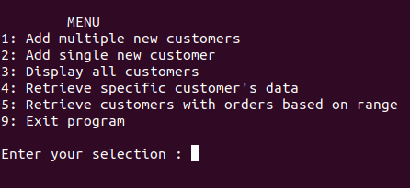

**Test Case 2: Add multiple new customers**

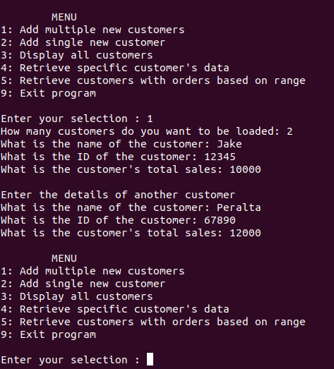

**Test Case 3: Add single new customer**

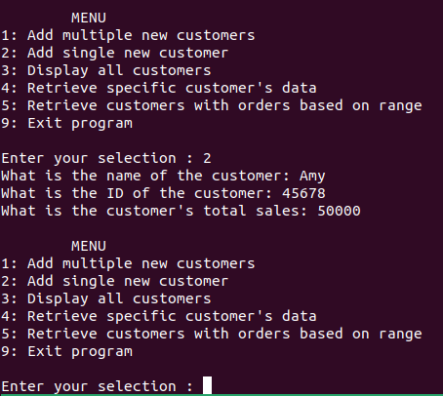

**Test Case 4: Display all customers**

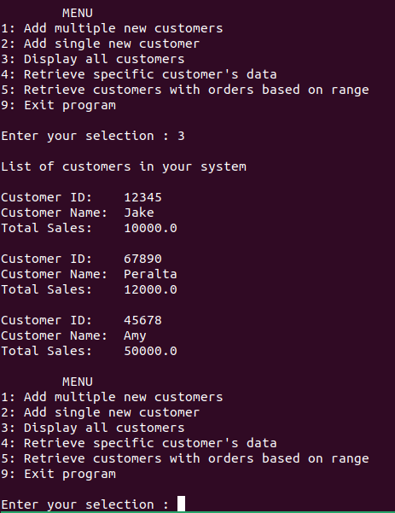

**Test Case 5: Retrieve specific customer data**

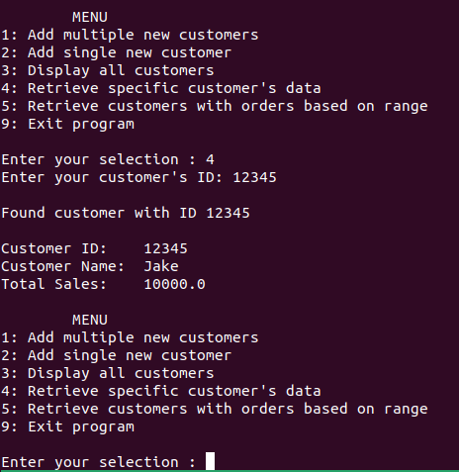

**Test Case 6: Retrieve customers with orders based on range**

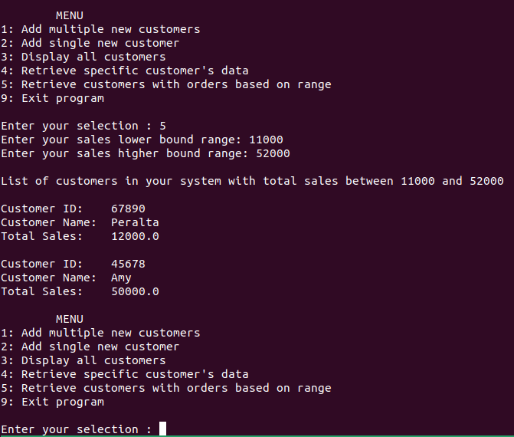

**Test Case 7: Exit**

